Analysis of Mitochondria Morphology
Data to Collect:
- Number of mitochondria
- Number of cristae per mitochondrion
- Length of mitochondria
- Area of mitochondria
- Number of mitochondria contact sites

Identifying mitochondria, cristae, and contact sites
- Mitochondria are distinguished by their dark outline due to the presence of a double membrane clearly seen in the boxed image on the left
- Mitochondria also contain cristae – dark lines present throughout the structure which are outlined in orange in the image on the right
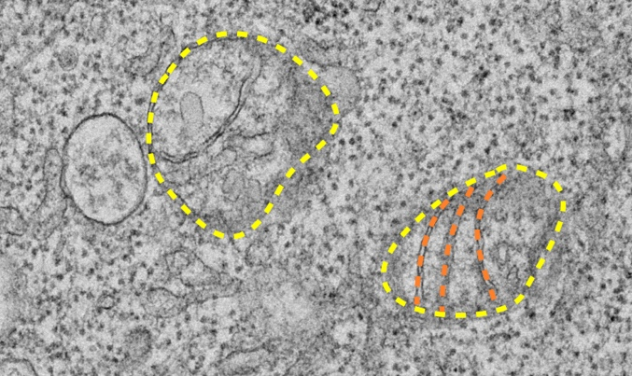
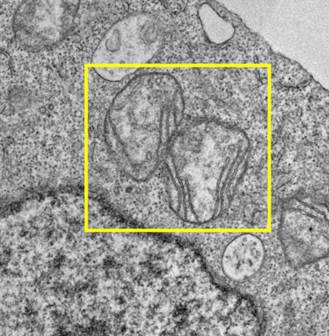
- Contact sites are instances where two different mitochondria are physically touching one another as seen in the highlighted box on the left

- Quantification: number of mitochondria, number of cristae per mitochondria, and number of mitochondria contact sites are manually counted and recorded for each image

Measuring Length and Area of Mitochondria
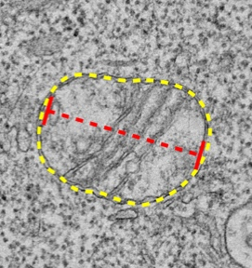
Length
- Using the “Straight” tool in ImageJ, click and drag a line between the farthest ends of the mitochondria as seen in the image to the right
- Go into “Analyze” and then click “Measure” to determine the length and record that value for every mitochondrion
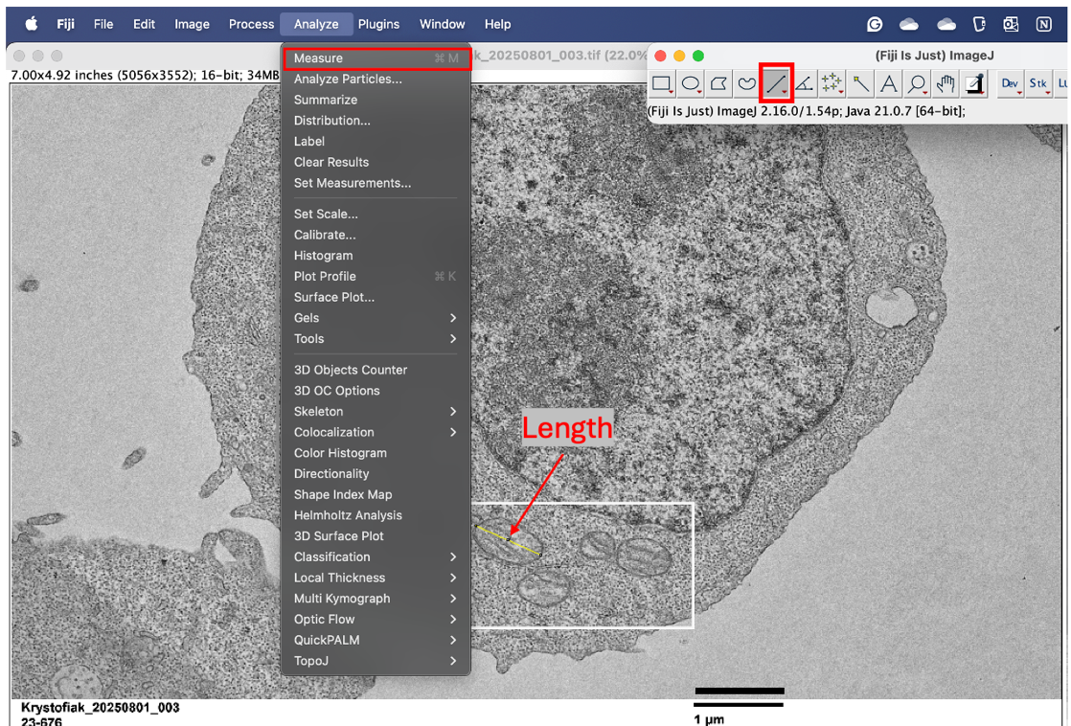
Area
- Using the “Freehand selections” tool (the bean shape) in ImageJ, manually trace around the mitochondria
- Go into “Analyze” and then click “Measure” to determine the area and record that value for every mitochondrion
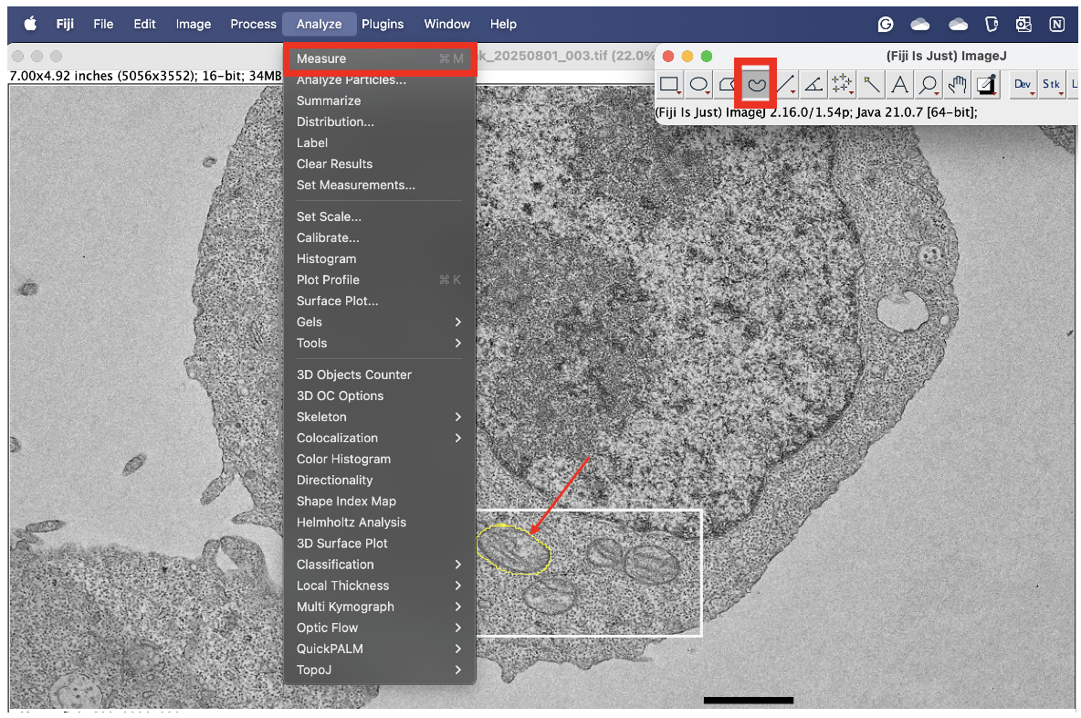

Analysis of Golgi Morphology
Data to Collect:
- Number of Golgi
- Area of the Golgi
- Distance from the Golgi to the nucleus

Identification of the Golgi and nucleus
- Golgi are identified by their “pancake stack” arrangement and tend to have multiple vesicles in close proximity to the structure as seen in the purple box below
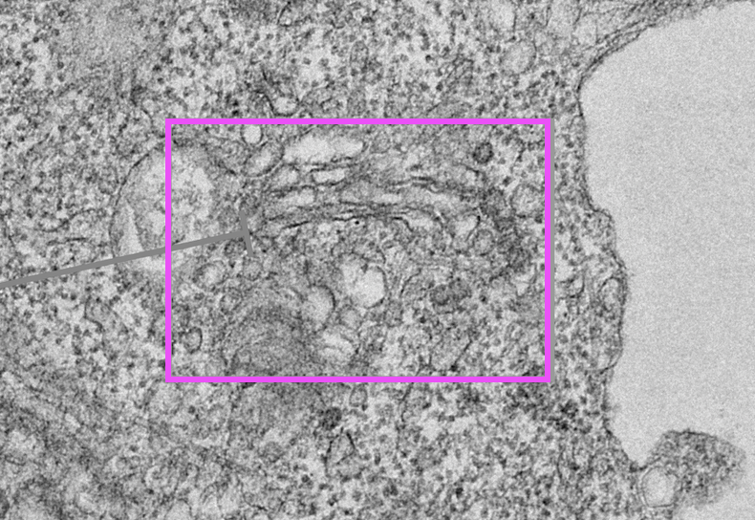
- Nuclei are easily identifiable as a massively large structure typically near the center of each cell with a thick, dark border and often dark “puncta” or clumps which lend it a granular appearance as seen in dark blue box in the image below
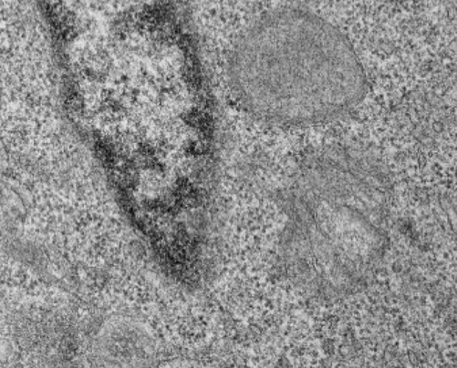
- Quantification: number of Golgi complexes were manually counted and recorded for each image

Measuring Area and Distance of the Golgi
Area
- Using the “Freehand selections” tool (the bean shape) in ImageJ, manually trace around the Golgi complex excluding any nearby vesicles to the best of your ability
- Go into “Analyze” and then click “Measure” to determine the area and record that value for each Golgi complex
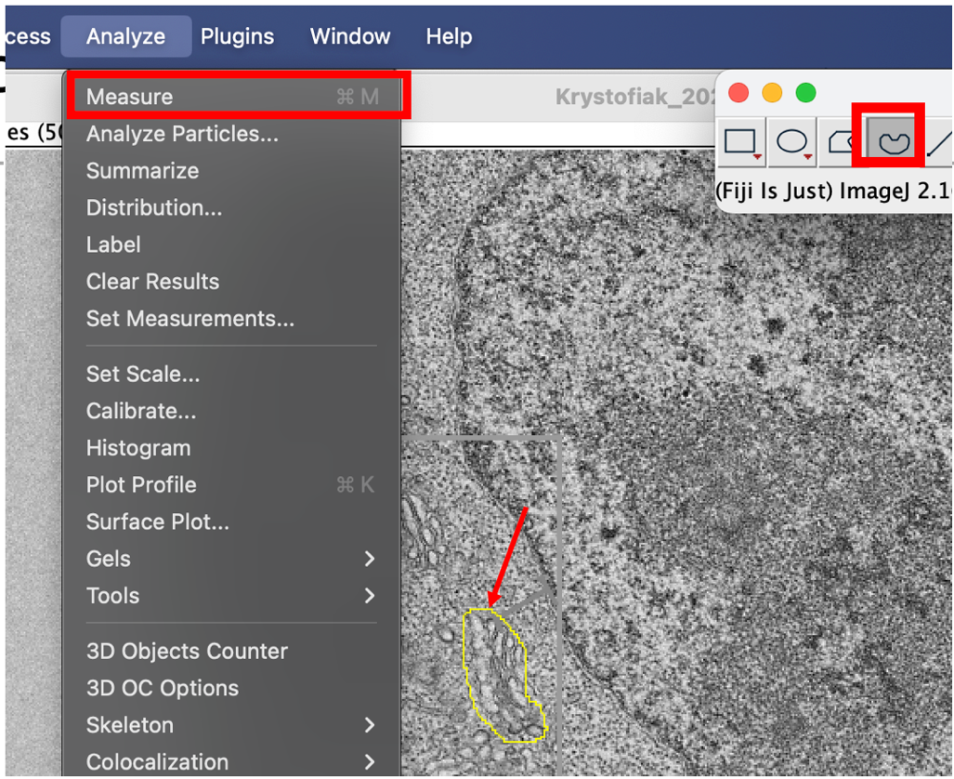
Distance from the nucleus
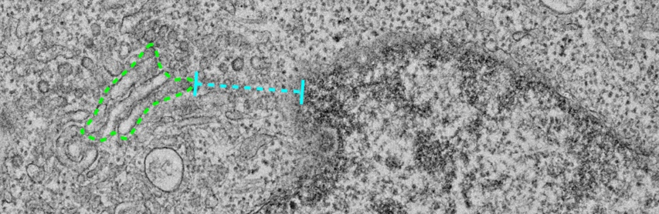
- Using the “Straight” tool in ImageJ, click and drag a line between the edge of the Golgi that is closest to the edge of the nucleus and the edge of the nucleus itself as seen with the cyan line below

- Go into “Analyze” and then click “Measure” to determine the distance and record that value for each Golgi complex
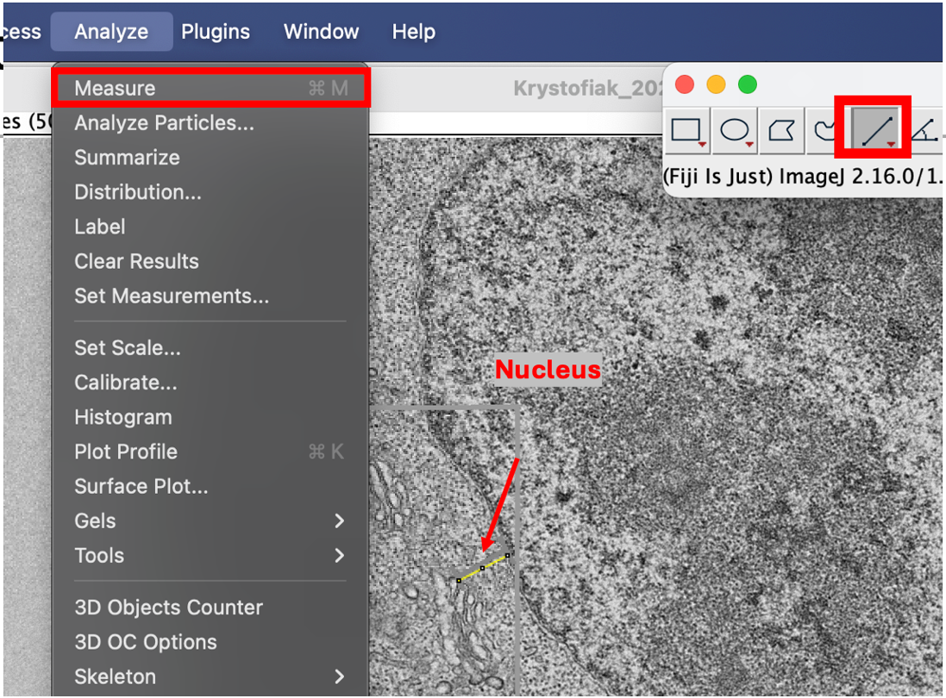

Converting ImageJ values to µm
- As ImageJ measurement are relative to pixel distance and area within the image itself, it is important to convert those values to biologically relevant numbers such as µm and µm²
- The scale bar of each image must therefore be measured in ImageJ and that number used to convert ImageJ values into µm
  - For example, if the scale bar is 1µm and has a measured length of 0.445 in ImageJ, all the determined lengths for that image must be divided by 0.445 to convert them to µm
    - careful! nm scale bars must be further converted into µm units, but I’ve already built that into the math below
  - List of common length/distance conversions:
    - 1um scale bar = divide by 0.445
    - 600nm scale bar = divide by 1.19
    - 500nm scale bar = divide by 1.49
    - 400nm scale bar = divide by 1.79
    - 200nm scale bar = divide by 2.20
  - When converting area, keep in mind that the values are not linear but are squared so the conversion must follow the same rule – for example, for an image with a 1µm scale bar, you cannot solely divide measured areas by the conversion factor 0.445, you must divide them by 0.445²

Statistical analysis of morphology data
- To draw any conclusions about the morphology quantification, the data must be plotted and statistically analyzed
- Step 1: Determine normality of the data
  - Why? As only two groups are being compared, the most commonly used statistical tests are T-tests and Mann-Whitney tests – broadly T-tests are used to compare two groups with a normal data distribution and Mann-Whitney tests are used to compare two groups which do not have a normal data distribution
  - Converted data values should be imported into GraphPad Prism as two columns with the appropriate headings
  - Go to “analyze” and select “analyze data”
  - Ensure your correct data table is selected on the right side and ensure the boxes are checked for both groups you are analyzing
  - Select normality and lognormality tests under column analyses on the left side
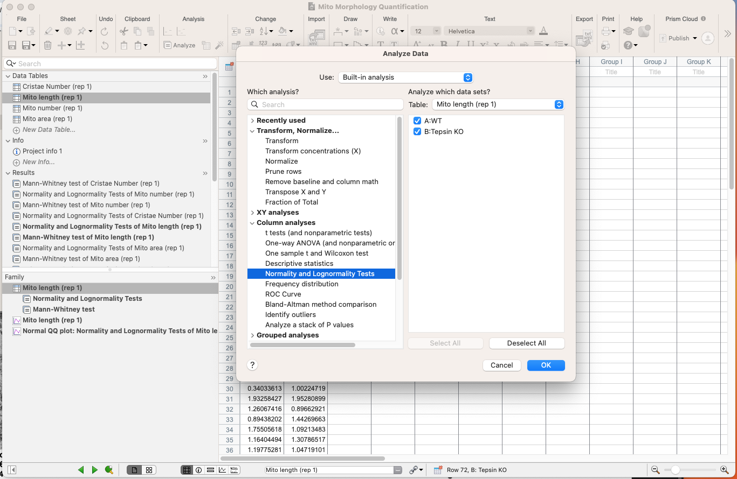
  - Ensure all the below parameters are selected and hit ok to run the analysis
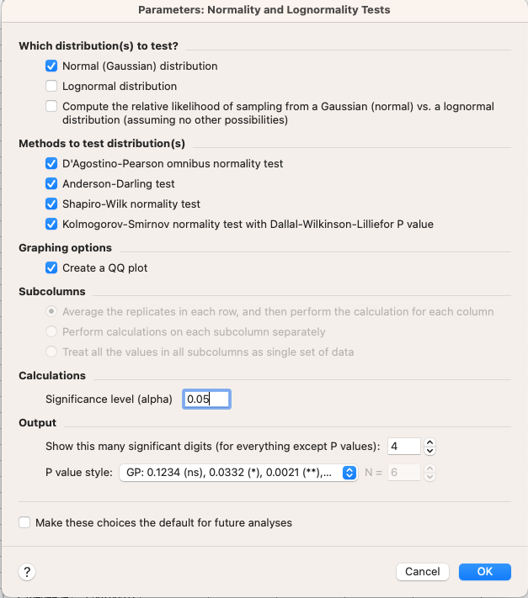
  - Prism will return the results of the analysis on a separate results sheet and if any of the four tests determine non-normality of the data – as indicated by failure to pass the normality test – consider the data non-normal
    - Note: for the most part this data will be non-normal!
- Step 2: Conduct comparative statistical test
  - If the data is normal, proceed with a T-test and if non-normal proceed with a Mann-Whitney U-test – this example will assume non-normality
  - Go to “analyze” and select “analyze data”
  - Ensure your correct data table is selected on the right side and ensure the boxes are checked for both groups you are analyzing
  - Select t tests (and nonparametric tests) under column analyses on the left side
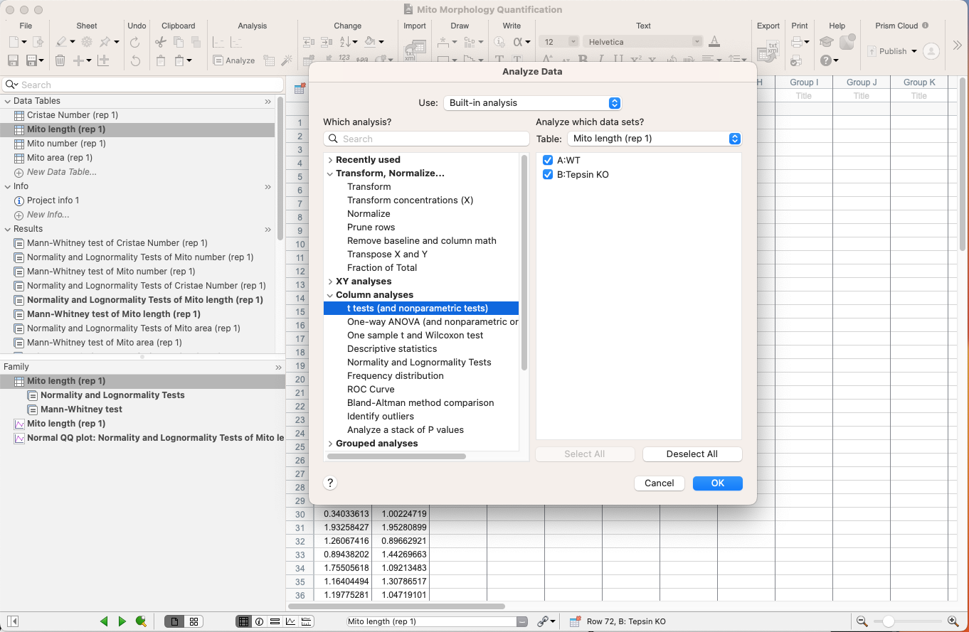
  - Ensure unpaired is selected, change the distribution assumption to nonparametric, and chose the Mann-Whitney test and hit ok to run the analysis
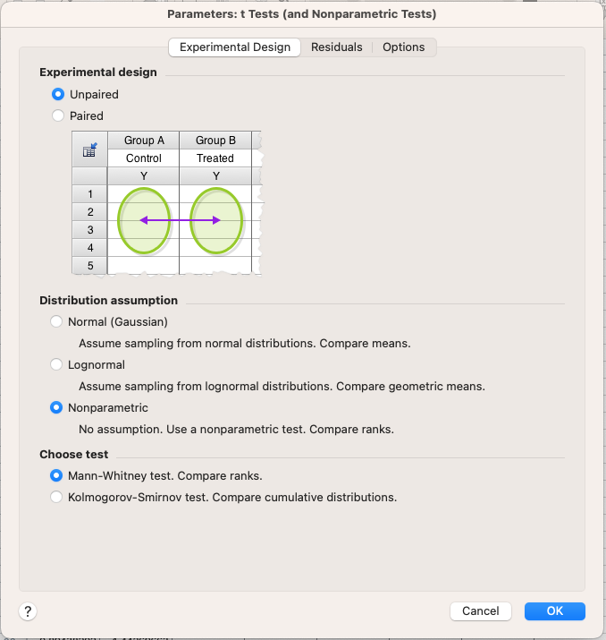
  - Prism will return the results of the analysis on a separate results sheet and take note of the calculated p-value
- Step 3: Plotting the data
  - Scroll down to the graph section and select the graph for the data table you are working on
  - Under graph type select the column graph family – violin plot – and violin plot show all points as the type of violin plot
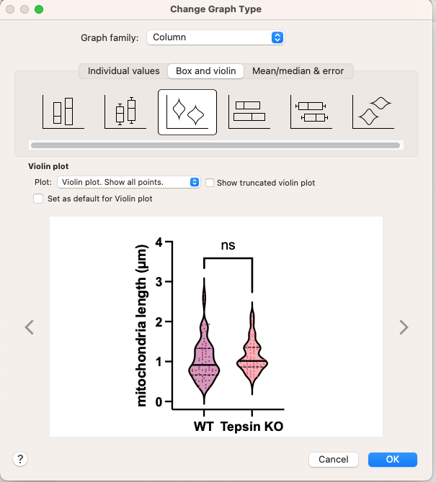
  - Double click on the axes or the data itself to format them and ensure the plot is easy to read and cleanly formatted – the specific format is up to the researcher’s discretion but as an example I’ve included my parameters for the plot below
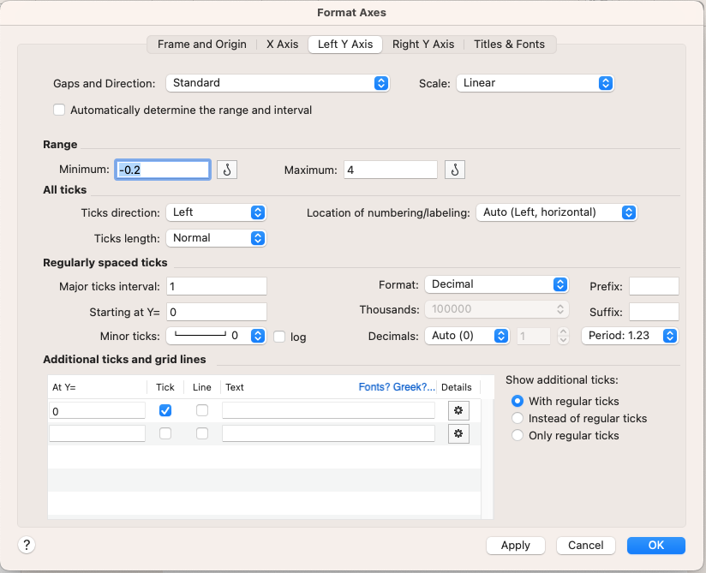
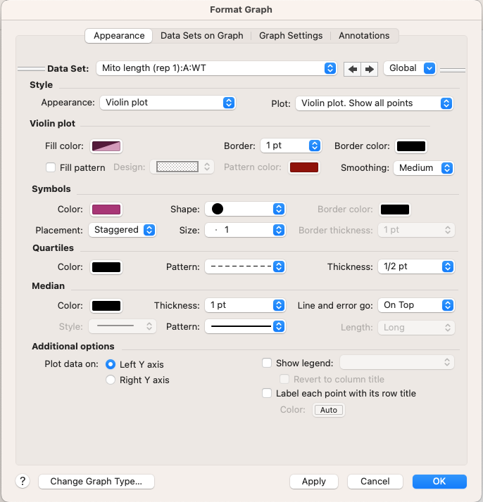
  - Finally, ensure your statistics are reported on the plot by clicking the bracket with the asterisk on top under the “draw” section which will automatically add in pairwise comparisons
